WEEK 5

Section A

1. Why do we split data into training and test sets, and what problem does this guard against?

We split data into training and test sets to evaluate how well a machine learning model performs on unseen data.
Training set: Used to train the model.
Test set: Used to evaluate the model after training.
This guards against overfitting, where the model learns the training data too closely and performs poorly on new data.

2. What is overfitting, and name two signs that a model is overfitting.
Overfitting occurs when a model learns the training data too closely, including its noise and small details, so it performs well on training data but poorly on unseen data.
Two signs of overfitting:
- Very high training accuracy but much lower test/validation accuracy.
- The model has low training errors but high test/validation errors.

3. Why can accuracy be misleading on an imbalanced dataset, and what metrics help instead?
Accuracy can be misleading on an imbalanced dataset because the majority of class dominates the results. A model may have high accuracy by predicting the majority class most of the time, while failing to correctly identify the minority class. Metrics such as precision, recall, F1-score, and the confusion matrix provide a better understanding of the model’s performance in each class.

4. What does a confusion matrix show, and how do precision and recall relate to it?

A confusion matrix is a table used to evaluate a classification model. It shows the number of correct and incorrect predictions by comparing the actual classes with the predicted classes.

For binary classification, it contains:
- True Positive (TP): Correctly predicted positive cases.
- True Negative (TN): Correctly predicted negative cases.
- False Positive (FP): Negative cases incorrectly predicted as positive.
- False Negative (FN): Positive cases incorrectly predicted as negative.
Precision and recall are calculated from these values:
- Precision = TP / (TP + FP): Measures how many predicted positives are actually positive.
- Recall = TP / (TP + FN): Measures how many actual positive cases the model correctly identifies.

Section B

1.Write the Pandas code to load a CSV, drop rows with missing values, and separate features from the label column.
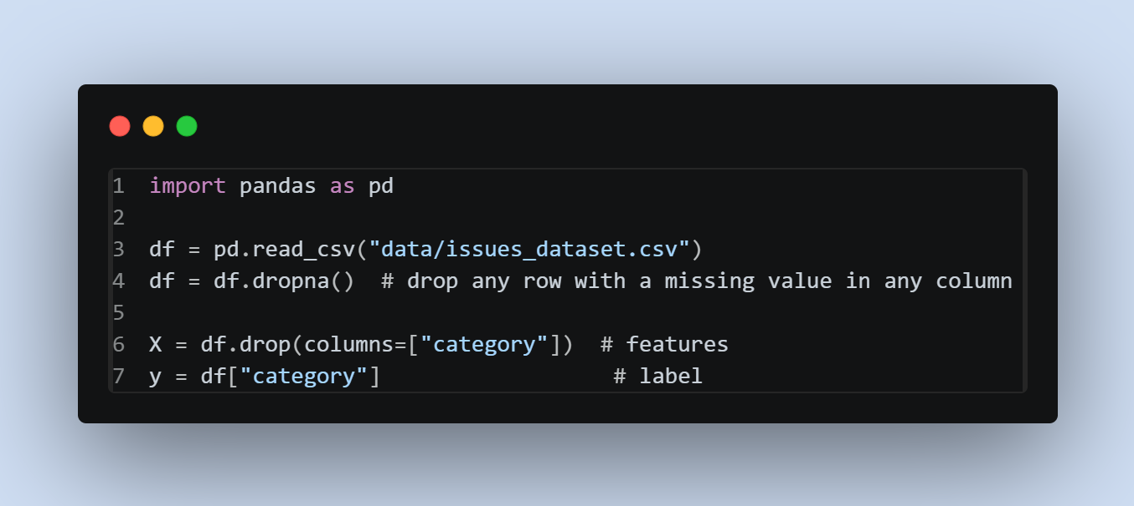

2. Write the scikit-learn code to split data, fit a model, and print an accuracy score.
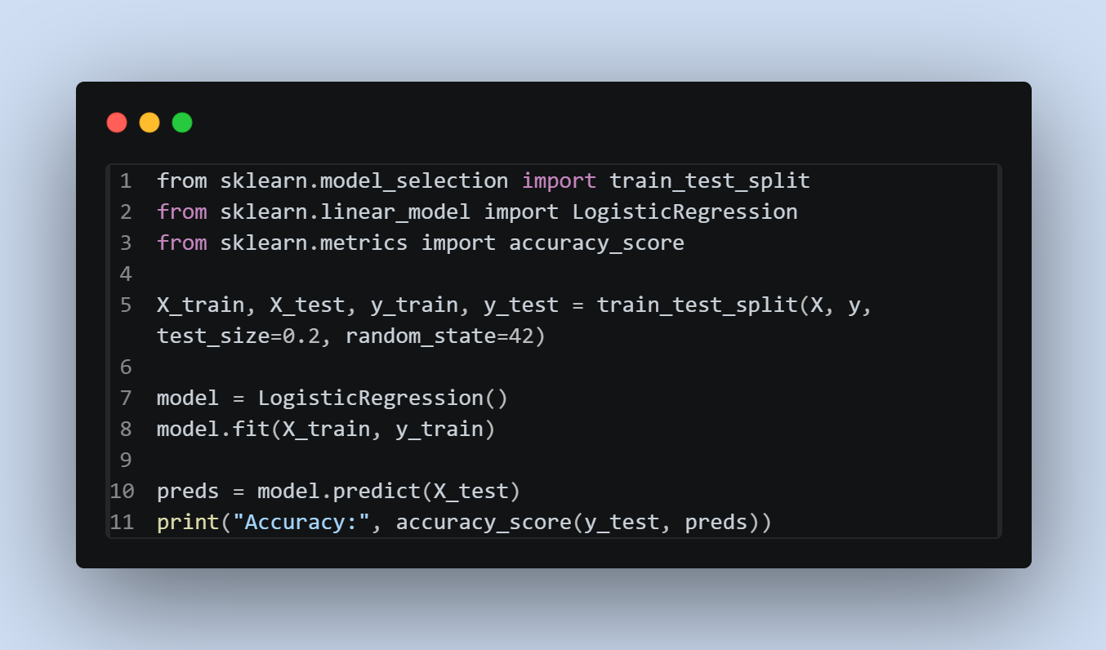
3. Write the code to save a trained model with joblib and load it again.
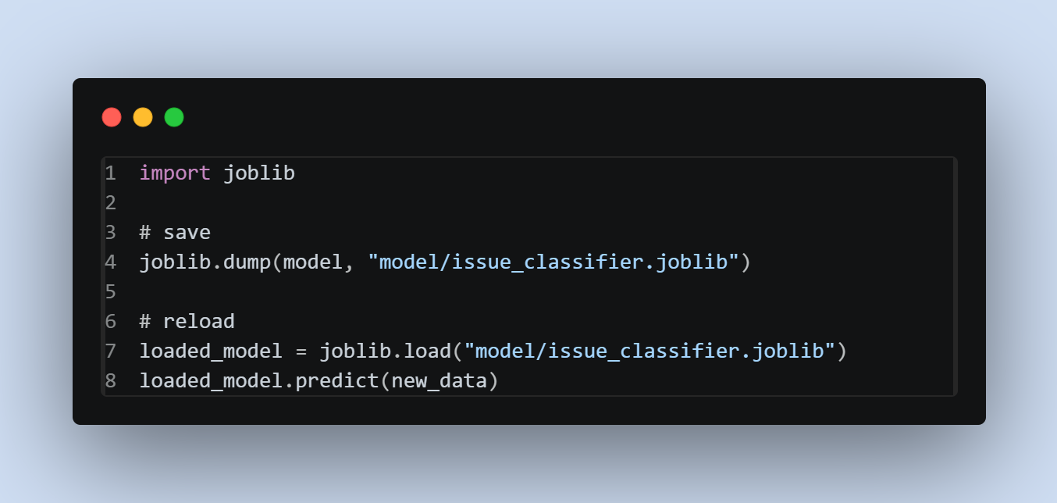

Section C

Train a model on a dataset of your choice, write two or three sentences interpreting the evaluation results honestly, and note one thing you would try to improve it

I trained a Logistic Regression and Naive Bayes classifier on a synthetic dataset of 220 issue titles/descriptions labeled by category (bug/feature/question/documentation), built specifically for my app. Both models scored 97.7% accuracy [tied] which is high enough to be suspicious, and honestly the dataset is templated synthetic text with fairly distinct vocabulary per category, so it is easier to separate than real world issue text would be. Running the saved model on genuinely new phrasing confirmed this, it misclassified a documentation complaint ("README doesn't explain how to set up the MongoDB connection") as a question, since it used question like wording. One thing I'd try to improve it. train on real GitHub issue text pulled from public repos via their API, which would have messier, overlapping language and force the model to generalize instead of pattern-match fixed templates.

